**Walkthrough Document:** [**Smart-Lead-Qualification-Workflow-n8n**](https://github.com/mhdSVU/-Smart-Lead-Qualification-Workflow-n8n-/upload/main)

**Date:** July 24, 2025

**Submitted By:** Mohammed Youser Sawwas

**Submitted To:**

### **1. Introduction**

This document accompanies the n8n workflow designed as a solution to the technical challenge, focusing on automating lead management processes. The workflow demonstrates capabilities in capturing lead data from a Tally.so form, dynamically scoring leads based on predefined criteria, storing lead information in Google Sheets , and initiating automated internal notifications and external customer follow-up.

### **2. Document Description**

This document serves as a comprehensive walkthrough of the submitted n8n workflow. It is structured to provide a clear understanding of the workflow's design, functionality, and underlying considerations. Specifically, this document includes:

* **Workflow Overview:** A diagram or screenshot illustrating the overall flow and connections between nodes.
* **Scoring Logic Description:** A detailed explanation of how leads are categorized into "Hot," "Warm," or "Cold" based on their submitted data.
* **Assumptions:** A list of key assumptions made regarding lead data, source, and external service configurations for the workflow's operation.
* **Limitations and Improvements:** An outline of the current workflow's inherent limitations, along with proposed enhancements and future development considerations to improve its functionality, robustness, and integration capabilities, including AI-related advancements for data validation.

### **3. Setup Requirements and Configuration Notes**

To ensure this workflow (MohammedSawwas N8N Expert REMWASTE) operates successfully within your n8n environment, please observe the following critical setup requirements:

* **Your Own Account Credentials:** You must configure your own credentials in n8n's 'Settings > Credentials' for the Google, **Slack** and **Email SMTP** services. The workflow uses named placeholders ('Slack Account' and ‘SMTP Account', respectively); n8n will prompt you to connect or create new credentials upon import. This secures your accounts.

**Note:**  
You can easily recognize the nodes where you need to configure the accounts with the help of notes I added, like the following one:  
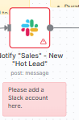

* **Slack Notification Configuration:** The Notify "Sales" - New "Hot Lead" Slack node sends immediate notifications. Ensure your Slack credentials have permission to post messages to the **desired user or channel** you select during configuration.
* **Tally.so Form Webhook:** This workflow is designed to receive submissions from the **publicly accessible:**

**Tally.so Form Link:** <https://tally.so/r/wMj9JX>  
  
 The Tally.so form is **already pre-configured** to send its submissions via webhook to this workflow's public URL. You don't need to perform any configuration within Tally.so itself; just ensure this workflow is active in your n8n instance.

* **Google Sheets Database Setup:** The workflow writes lead data to a **provided, publicly editable Google Sheet**: <https://shorturl.at/DMiUy>  
   You don't need to create a new Google Sheet. Simply ensure your n8n instance has a valid 'Google Sheets API' credential connected, with permissions to write to this public sheet.

**Workflow Overview:**

The following diagram or screenshot illustrates the overall flow and connections between nodes.

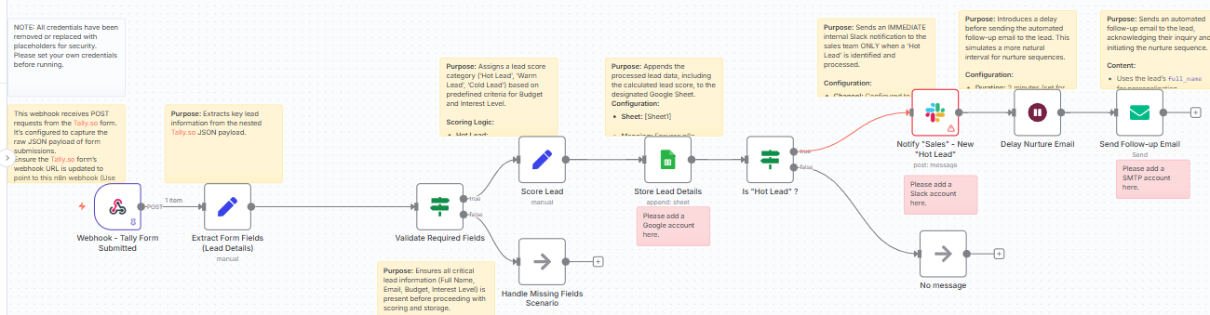

(MohammedSawwas N8N Expert REMWASTE Workflow diagram)

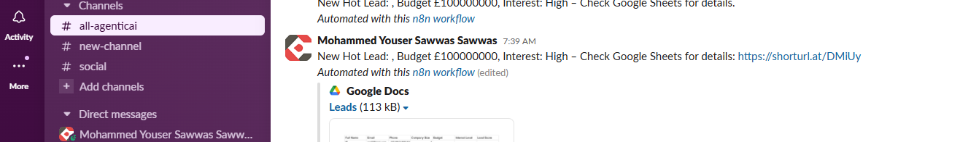

**(Slack Message)**

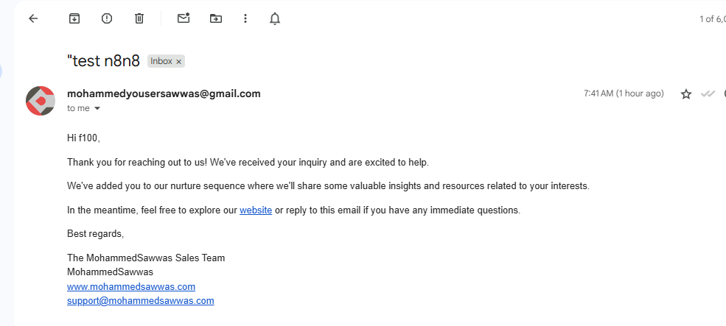

**(Follow-up Email Message)**

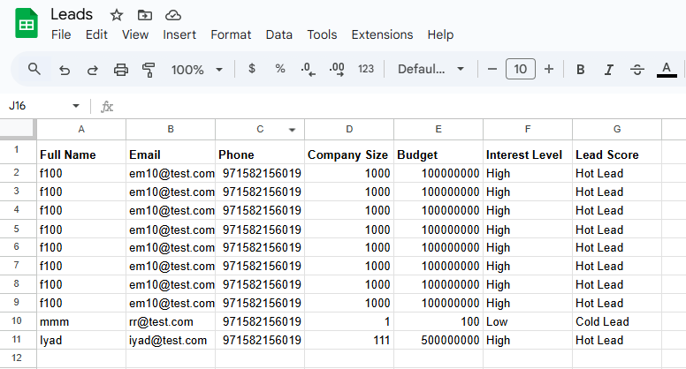

**(Google Sheet)**

**Lead Scoring Logic:**

The lead scoring system categorizes incoming leads from Tally.so submissions into one of three tiers: **"Hot Lead," "Warm Lead,"** or **"Cold Lead."** This categorization is based on two primary factors: the **budget** the lead indicates and their **interest_level**.

Before evaluation, it's assumed that:

* The budget value is already a numerical type.
* The interest_level value is a string with consistent casing (e.g., "High", "Medium", "Low") and no leading/trailing spaces.

Here are the specific rules:

1. **Hot Lead:**
   * A lead is classified as **"Hot Lead"** if:
     + Their budget is strictly greater than £7,500 **AND**
     + Their interest_level is exactly "High".
2. **Warm Lead:**
   * If a lead is *not* a "Hot Lead", the system then checks if they are a **"Warm Lead"**. A lead is "Warm Lead" if:
     + Their budget is greater than or equal to £2,500 **AND** less than or equal to £7,500 **AND** their interest_level is either "Medium" or "High".
     + **OR**
     + Their budget is strictly greater than £7,500 **AND** their interest_level is exactly "Medium".
3. **Cold Lead:**
   * Any lead that does **not** meet the criteria for either a "Hot Lead" or a "Warm Lead" is automatically classified as a **"Cold Lead"**. This serves as the default category for all other combinations of budget and interest level.

In essence, the system prioritizes "Hot Leads" first. If a lead doesn't fit the "Hot" criteria, it then checks for "Warm" criteria. If neither of those apply, the lead defaults to "Cold."

### **Workflow Documentation: Assumptions, Limitations, and Improvements:**

This section outlines the underlying assumptions made during the development of the n8n lead management workflow, its current limitations, and proposed areas for future enhancement.

### **1. Assumptions**

The following conditions are assumed for the workflow to operate as designed:

* **Lead Source:** The primary lead source for this workflow is exclusively **submissions from the specified Tally.so form via webhook**.

**Tally.so Form Link:** <https://tally.so/r/wMj9JX>

The workflow's initial data extraction and parsing are specifically tailored to the JSON structure of webhooks originating from this form.

* **Data Consistency & Format:**
  + The budget field provided by Tally.so is assumed to be in a **numerical format** suitable for direct mathematical comparisons.
  + The interest_level field from Tally.so is assumed to have **consistent casing** (e.g., "High", "Medium", "Low") and **no leading/trailing whitespace**, allowing for direct string comparisons.
* **Testing Data:** Any data used during testing, particularly for email sending and database storage, is understood to be **non-production, test data**.
* **External Service Configuration:** All integrated external services (Tally.so webhook, Google Sheets/Airtable, Slack, Email SMTP) are assumed to be **pre-configured and operational** with valid credentials. The target Google Sheet or Airtable Base/Table is assumed to exist with the expected column headers.
* **Workflow Trigger:** The n8n instance is assumed to be **continuously active and listening** for webhook triggers to ensure timely lead processing.

### **2. Limitations**

The current workflow, while functional, has the following limitations:

* **Basic Validation:** The workflow only verifies the *presence* of key fields (Full Name, Email, Budget, Interest Level). It lacks advanced validation for data types (e.g., email format, positive numerical budget) and does not prevent duplicate submissions based on unique identifiers like email addresses.
* **Simple Scoring Logic:** Lead scoring is based solely on predefined budget and interest_level rules. It does not incorporate additional lead qualifying factors (e.g., company size, role, specific product interest, geographical location) or dynamic scoring based on post-submission lead behavior.
* **Generic Nurturing:** The automated follow-up email is generic and sent to all leads after a fixed delay, regardless of their calculated lead score. This limits personalized engagement for different lead tiers. The nurture sequence is also confined to a single immediate email.
* **No Duplicate Handling:** The workflow currently appends every form submission as a new record in the database (Google Sheets/Airtable), without checking for or updating existing lead entries.
* **Limited Error Handling:** While a basic validation check exists, the workflow does not include comprehensive error handling for issues like external service failures (e.g., Slack API errors, database write failures) or unexpected data formats, which could lead to workflow termination without explicit alerts.
* **Scalability for High Volume:** For extremely high volumes of incoming leads, the current sequential processing might require optimization to prevent bottlenecks.

### **3. Proposed Improvements**

To enhance the workflow's robustness, intelligence, and business value, the following improvements are recommended:

* **Advanced Data Validation & AI-Enhanced Fraud Detection:**

a. Add numeric range or type checks for budget to ensure valid numerical input.

b. Implement regular expressions for robust basic email format validation.

c. **Enhance validation by integrating with an AI-powered email validation or fraud detection service.** These services go beyond basic syntax checks, using machine learning to identify:

* + **Disposable or temporary email addresses** (common in fake submissions).
  + **Bot-generated or fraudulent email patterns.**
  + **Email deliverability issues** (reducing bounce rates and improving data hygiene).

This provides a much stronger defense against fake or low-quality lead data at the point of entry.

* **Action:** Incorporate Function or Code nodes with regex, augmented by integration nodes for services like ZeroBounce, NeverBounce, or other anti-fraud/email validation APIs.
* **Duplicate Lead Management:**
  + Introduce a step to check for existing leads (e.g., by email address) in the database before creating a new record.
  + If a duplicate is found, update the existing lead's information (e.g., score, last submission timestamp) instead of creating a new entry.
  + **Action:** Add database 'Read' or 'Find' nodes followed by conditional logic (IF node) to branch to 'Update' or 'Append' actions.
* **Tiered Nurture Sequences:**
  + Develop distinct nurture paths using conditional branching based on the lead_score_category.
  + **Hot Leads:** Trigger immediate, personalized sales tasks in a CRM and potentially direct outreach from a sales representative.
  + **Warm Leads:** Enroll in a targeted, multi-stage automated email campaign (e.g., a series of emails with relevant content over a defined period).
  + **Cold Leads:** Add to a general marketing newsletter or a longer-term, less frequent re-engagement track.
  + **Action:** Implement additional IF nodes and specialized email/CRM automation sequences.
* **Robust Error Reporting & Alerts:**
  + Configure global error workflows within n8n to send immediate notifications (e.g., via Slack or email) to administrators upon any workflow execution failure.
  + Implement explicit error handling for specific failure points within the main workflow branches.
  + **Action:** Utilize n8n's 'Error Workflow' feature and add dedicated error handling sub-branches.
* **Full CRM Integration:**
  + Integrate with a dedicated Customer Relationship Management (CRM) system (e.g., HubSpot, Salesforce, Pipedrive) to manage lead creation, updates, ownership assignment, and trigger CRM-native sales automation.
  + **Action:** Replace or augment current database storage nodes with specific CRM integration nodes.
* **Enhanced Personalization & Dynamic Content:**
  + Leverage additional form fields (e.g., industry, company size, specific product interest) to further personalize follow-up communications and nurture content.
  + **Action:** Ensure these fields are captured from the lead source and dynamically inserted into email templates or used to segment nurture tracks.